

**Heaven's Light is Our Guide**

**RAJSHAHI UNIVERSITY OF ENGINEERING & TECHNOLOGY**

**Department of Computer Science & Engineering**

**Project Report**

**Course Code :** CSE 2100

**Course Name :** Software Development Project I

**Project Title :** TrackMyStudy

**Platform :** Android

|  |  |
| --- | --- |
| Submitted by Md. Rubayat Ahsan  Roll : 2203096  Section : B  Series : 22 | Submitted to  Rizoan Toufiq  Associate Professor Department of CSE  RUET |

**Date of Submission:** 15 April 2025

**Overview**

**TrackMyStudy** is an Android app designed to help students build effective study habits and stay organized academically. It allows users to track study time, manage coursework, and monitor deadlines efficiently. By fostering discipline and reducing procrastination, the app empowers students to achieve academic success. With intuitive tools and reliable performance, TrackMyStudy is an essential companion for students striving to excel.

**Project Objectives**

1. To enable students to monitor and optimize their daily study sessions efficiently.
2. To streamline the organization of course materials and academic assessment records.
3. To provide timely reminders for upcoming exams and key academic deadlines.

**Key features**

1. Built-in stopwatch to track-focused study sessions
2. Add or delete course and exam names
3. Calculate the average of the best three CT marks
4. Real-time countdown timer for upcoming exams
5. Clean and user-friendly interface

**Step-by-Step Feature Overview**

**Main Menu Overview:** Upon launching the app, users are greeted with a clean and straightforward main menu. It features three key options: Study Pulse, CT Analyzer, and Exam Alert - making it easy to access the app's core functionalities.

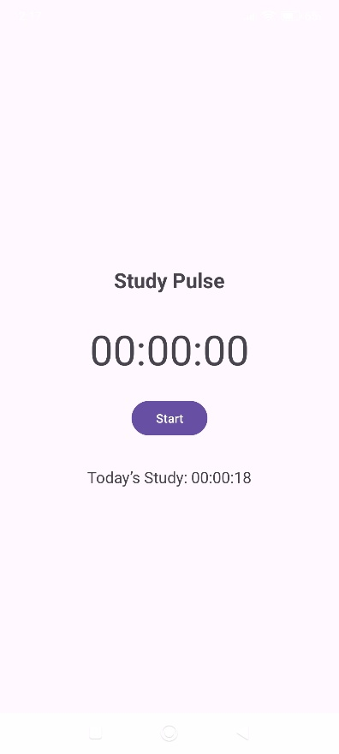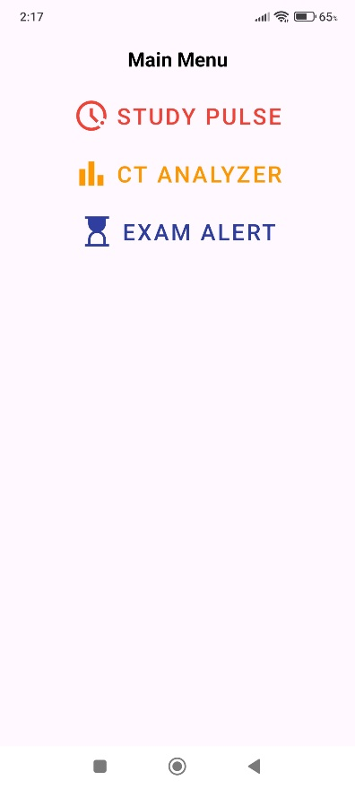 Figure 1: Main Menu Screen Figure 2: Study Pulse Screen

**Study Pulse Overview:** Tapping Study Pulse opens a stopwatch interface with Start/Stop controls for timing study sessions. Below the timer, a summary line displays the total study time logged for the current day (12 AM–11:59 PM), helping students see exactly how much they’ve studied in the last 24 hours.

**CT Analyzer Overview:** Tapping the CT Analyzer option opens a blank screen with an Add button. When users tap this button, they are prompted to enter and save a course name. Once saved, selecting the course opens a new screen containing four input fields for entering CT (Class Test) marks. At the bottom, there is a "Calculate Best 3 Average" button. After entering all four marks and tapping the button, the app automatically calculates and displays the average of the best three scores, helping students monitor their academic performance efficiently. Additionally, swiping the course name to the right will delete it with confirmation, while swiping it to the left allows users to update the course information.

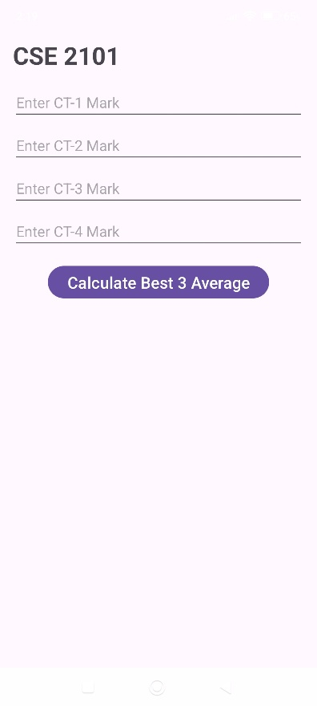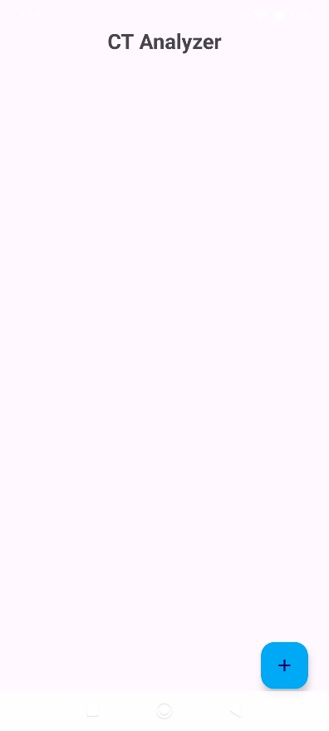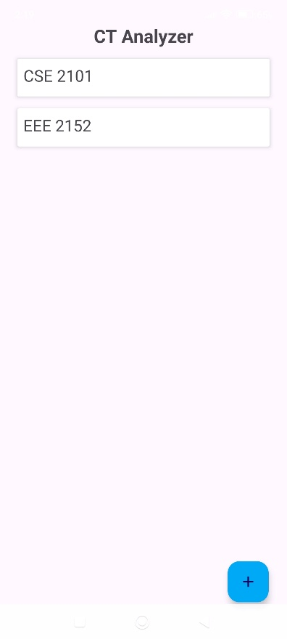Figure 3: CT Analyzer Screen

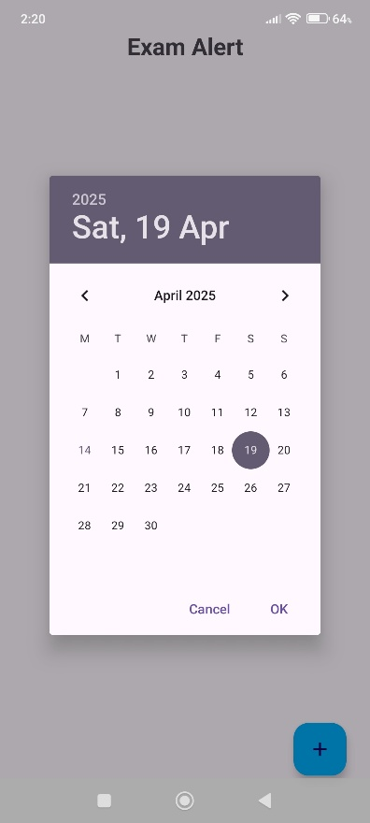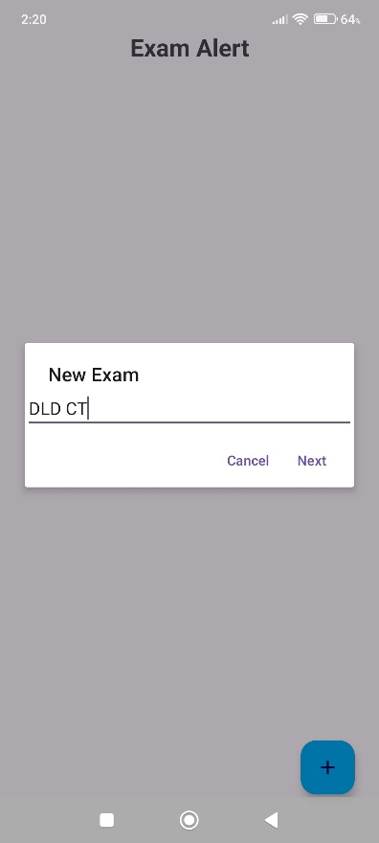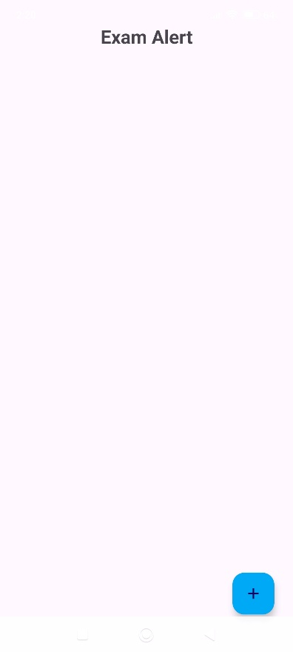

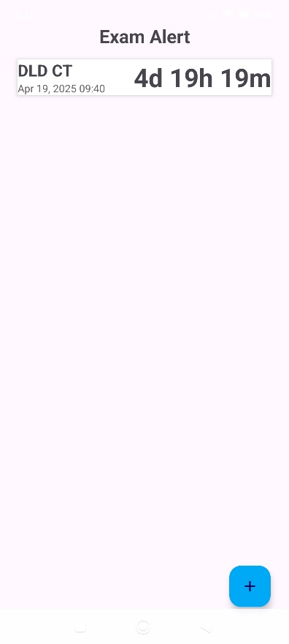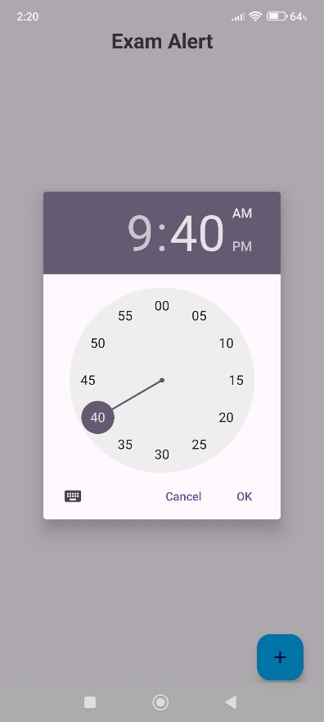  
Figure 4: Exam Alert Screen

**Exam Alert Overview:** Tapping the Exam Alert option opens a blank screen with an Add button. When users tap this button, they are prompted to enter and save an exam name. Next, they select the exam date and time using the provided pickers. Once saved, the exam appears in a list with a real‑time countdown timer showing days, hours, and minutes remaining. To delete an exam, the user swipes the entry to the right and confirms the deletion in the dialog that appears, keeping the exam list up to date.

**Conclusion**

TrackMyStudy is an easy‑to‑use Android app that helps students track their study time, organize coursework, and stay on top of deadlines with real‑time reminders and performance insights. Promoting disciplined study habits and offering quick access to key academic data, boosts productivity and supports better grades. In a crowded market of study tools, TrackMyStudy stands out for its simplicity and focus on core student needs—time management and performance tracking. With upcoming features like cloud sync and deeper analytics, the app will grow into a full‑featured academic companion, cementing its role as an essential resource for student success.